1. Churn Distribution
Figure Title: Distribution of Customer Churn in Next 60 Days
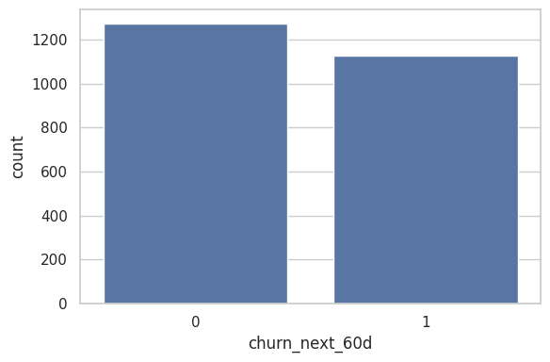

Interpretation: The plot shows the proportion of customers who churned vs retained. If imbalance exists, modeling techniques should address class imbalance.

2. Total Orders vs Churn
Figure Title: Relationship Between Total Orders and Churn
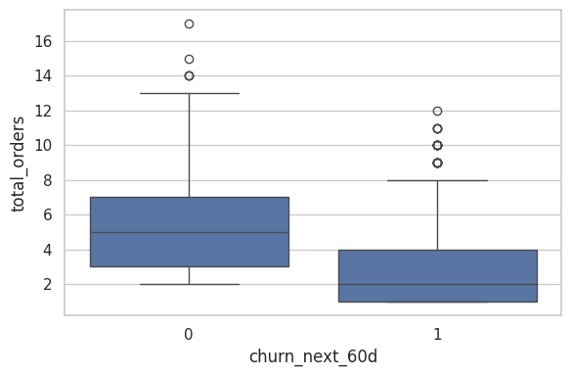
Interpretation: Customers with fewer orders tend to churn more, indicating lower engagement. High-frequency buyers are more loyal.

3. Total Spend vs Churn
Figure Title: Relationship Between Total Spend and Churn

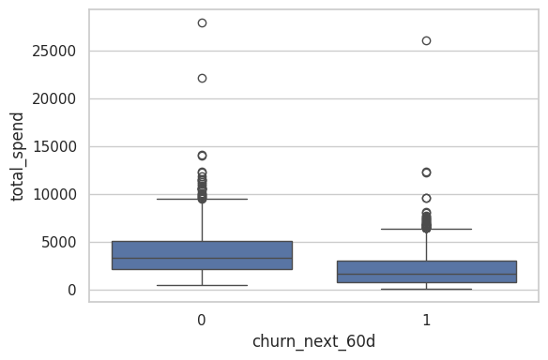
Interpretation: Lower spending customers are more likely to churn, suggesting high-value customers are more retained.

4. Recency vs Churn
Figure Title: Impact of Recency on Customer Churn

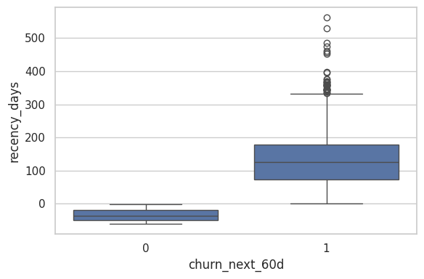
Interpretation: Customers with higher recency (long time since last order) show higher churn probability.

5. Support Tickets vs Churn
Figure Title: Support Ticket Count vs Customer Churn

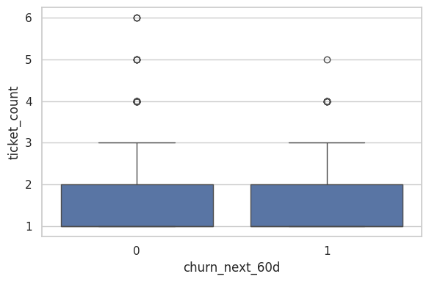
Interpretation: Higher ticket counts may correlate with churn due to dissatisfaction.

6. Sentiment vs Churn
Figure Title: Average Support Sentiment vs Churn

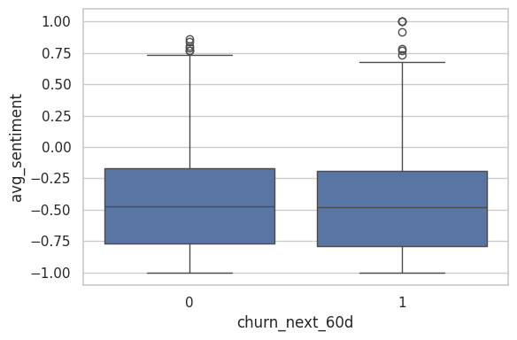
Interpretation: Lower sentiment scores indicate negative interactions and higher churn likelihood.

7. Website Sessions vs Churn
Figure Title: Website Engagement (Sessions) vs Churn

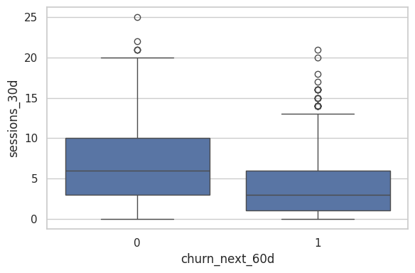
Interpretation: Fewer sessions indicate low engagement and higher churn risk.

8. Last Visit vs Churn
Figure Title: Days Since Last Visit vs Churn

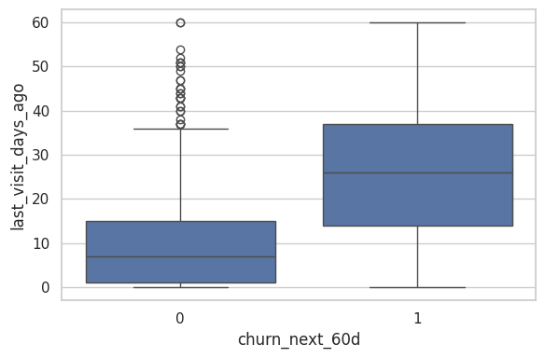
Interpretation: Customers who haven’t visited recently are significantly more likely to churn.

9. Loyalty Tier vs Churn
Figure Title: Churn Distribution Across Loyalty Tiers

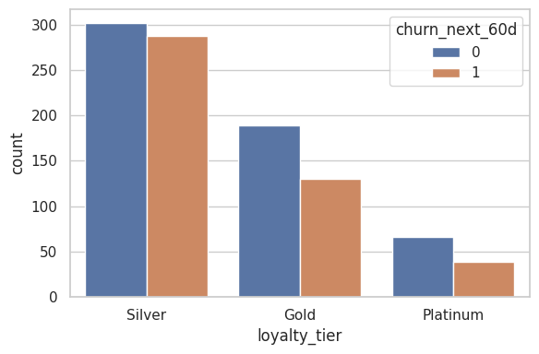
Interpretation: Higher loyalty tiers usually have lower churn due to benefits and stronger engagement.

10. Campaign Impact
Figure Title: Effect of Campaign Exposure on Churn

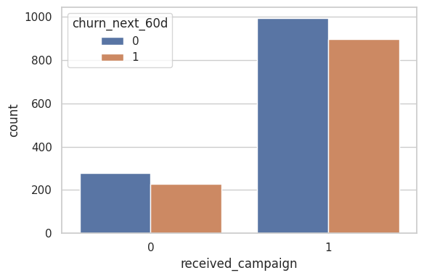
Interpretation: Customers receiving campaigns may show reduced churn if campaigns are effective.

